1. In microservice, there is a chain of calls from one micro to another. 
   1. What would happen if microservice4 is down or slow?
   2. **Answer**: There would be impact on the entire chain.
2. **Question**: Can we return a fallback response if a service is down?
3. **Answer**: Yes, we can configure a fallback response.
   1. But this doesn’t make sense always.
   2. For example, in case of credit card transaction.
   3. But in e-commerce app, instead of returning a set of products as per criteria you can return a default set of products.
4. 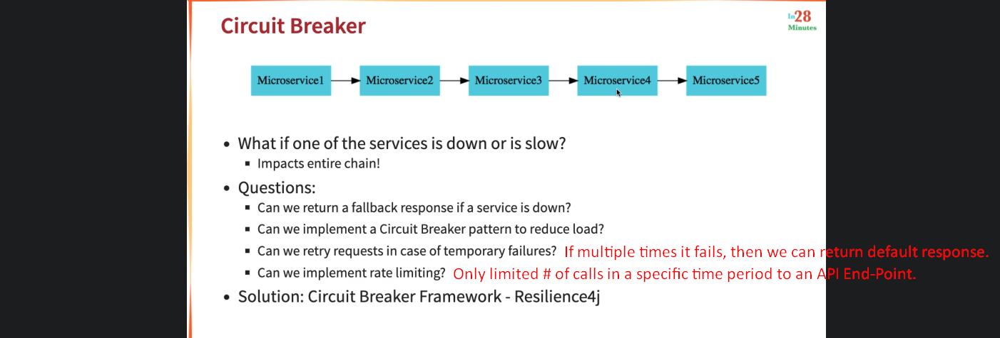
5. 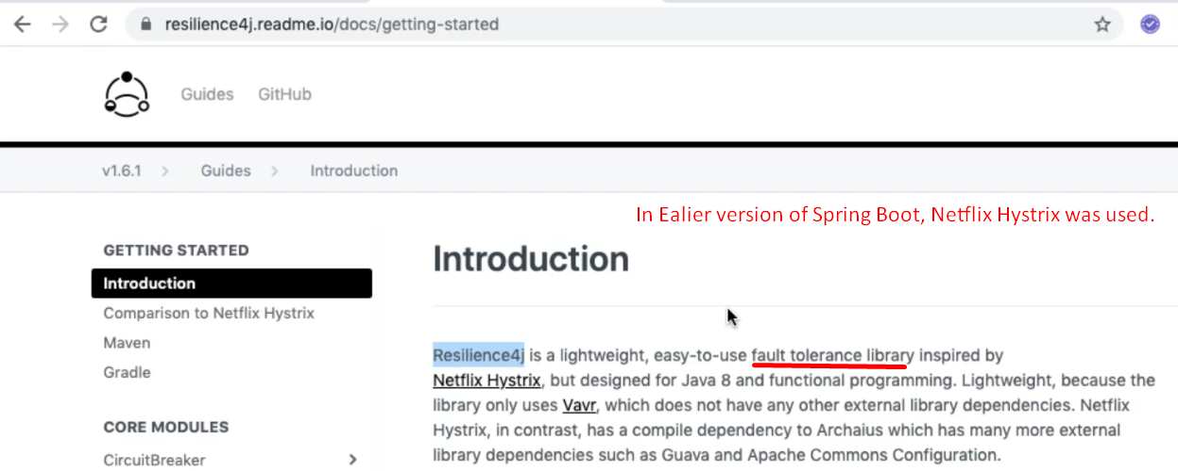
6. NOTE: We will add a new API in Currency Exchange Microservice.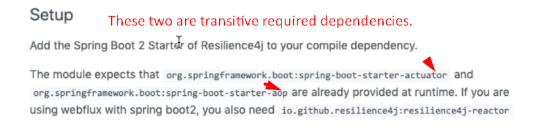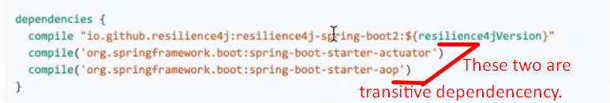
7. 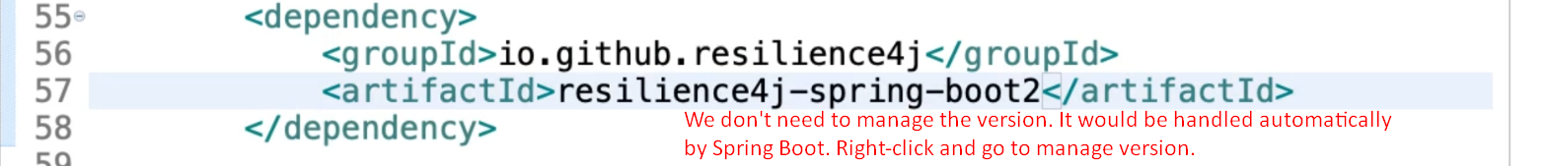  
   Add these two dependencies to pom.xml file.
8. 